Following Agile design practices, we made numerous improvements and modifications to the system throughout the design processes. Many of these were identified through our tests with the sounders FC and the Seattle EOC

Configurability of the usability framework.

Before we underwent our sports mobile app comparison we were limited to utilizing the entire 40 attribute TEDS framework. However, after some initial tests amongst the expert raters, we determined that 40 attributes would far too many for non-expert raters. So, we improved the system to take any configuration of attributes and to allow for the clustering of attributes so we could provide a shorter more refined survey.

Demographic Questions

Similarly, during our transition over into non-expert raters. It was clear that, if we wanted to distribute these remotely - through the internet and advertising - it would be difficult to purposefully sample them before taking the survey. As such, we added the demographic questions so we many break apart our larger sample afterwards.

Social marketing through reinforcement of the incentives

After our non rater tests of the Sounders FC mobile app it was obvious that we needed to leverage our advertising budget further. While we were fairly content with our click through rate. We did little to market ourselves after the user had entered our site. This gave them little motivation to continue. To improve this, we decide to reinforce our lottery incentive system by improving the final screen of each assessment with information about the lottery, if the survey is apart of it. We hope this will provide us some social marketing and more invested users.

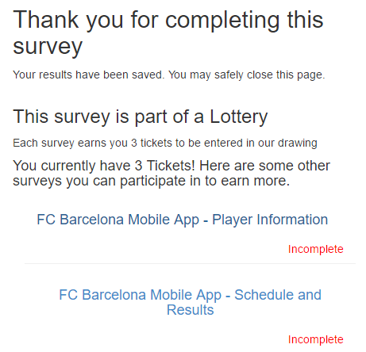

Randomizations of the order in which attributes and scenarios presented

Similarly, After our tests with non-experts we noticed many users stopping after the first few attributes and a few more dropping off after the first assessment. This seemed problematic and could potentially skew our data. So, to reduce this bias we decided to randomize the order of the attributes in each assessment and to randomize the order of the configurations in each group page.

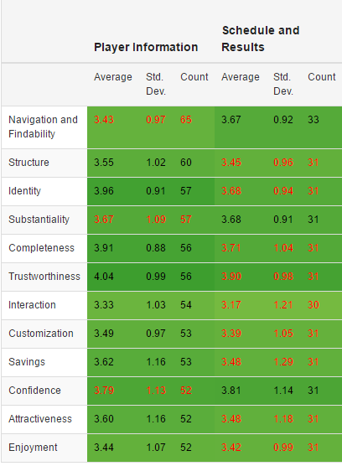

Stats and reporting

Throughout the design process it was evident that we would need an extensive data visualization and statistical analysis system for our attribute rating. As we improved the system, we identified areas other than the attribute rating which required visualizing: these being comments, screenshots, and demographic questions. Adding these visalization has helped administrators identify issues with the data or the application being tested earlier and has given us better insight into the rating process… While we currently feature a robust visalization system, our automated statistical analysis is still in progress. To circumvent this we allow admins to export project data so they may do tests in other software systems. However, we plan to implement automated and push-button Chi-Squared, Anova, kruskal Wallace, T-Test and regression testing.

Ui changes (small)

Progress bar

Noticability of the Scenario in progress